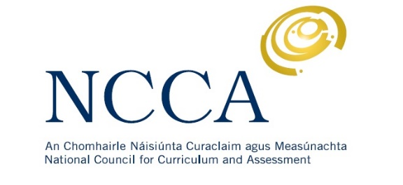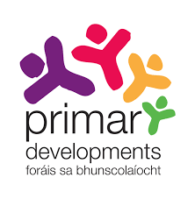

Primary Curriculum Review and Redevelopment
Written submission template for organisations, groups and individuals responding to the Draft Primary Curriculum Framework
This template is intended to support you (and your colleagues/organisation) in developing a written submission in response to the Draft Primary Curriculum Framework. Please e-mail your completed submission to PCRRsubmissions@ncca.ie
Individual submission details
Name
Date
E-mail

Organisation submission details
Name
Position
Organisation
Date
E-mail

The NCCA will publish written submissions received during the consultation. The submissions will include the author’s/contributor’s name/organisation. Do you consent to this submission being posted online?
Yes No

Please provide some brief background information on your organisation (if applicable).

The remainder of the template includes two sections. Section 1 invites your overall comments and observations on the Draft Primary Curriculum Framework. Section 2 is structured to align with the six key messages related to the framework. Each message is summarised as a support for you in working on the submission.
  - Section 1
Please outline your overall response to the Draft Primary Curriculum Framework.

  - Section 2
Agency and flexibility in schools
The Draft Primary Curriculum Framework proposes that the redeveloped curriculum will:
- Be for every child.
- Recognise teachers’ and principals’ agency and professionalism to enact the curriculum in their individual school context.
- Give more flexibility to schools in terms of planning and timetabling to identify and respond to priorities and opportunities.
- Connect with different school contexts in the education system.
- Give greater opportunities for flexibility and choice for children’s learning.

The Draft Primary Curriculum Framework outlines important messages in relation to agency and
flexibility in schools. Please give your overall feedback in relation to this key message.

Curriculum connections between preschool, primary and post-primary schools
The Draft Primary Curriculum Framework proposes that the redeveloped curriculum will:
- Provide a clear vision for children’s learning across the eight years of primary school.
- Link with learning experiences provided through the themes of the Aistear: the Early Childhood Curriculum Framework and connect with the subjects, key skills and statements of learning in the Framework for Junior Cycle.
- Support educational transitions by connecting with what and how children learn at home, in preschool and post-primary school.
The Draft Primary Curriculum Framework outlines important messages in relation to curriculum connections between preschool, primary and post-primary schools. Please give your overall feedback in relation to this key message.

Emerging priorities for children’s learning
The Draft Primary Curriculum Framework proposes that the redeveloped curriculum will:
- Embed seven key competencies across children’s learning outcomes from junior infants to sixth class.
- Focus on developing children’s skills, knowledge, dispositions, values and attitudes. The Learning Outcomes and the Key Competencies are broad in nature to describe this wider understanding of learning.
- Have increased emphasis on some existing areas such as PE and SPHE (Wellbeing) and digital learning, and have new aspects such as Modern Foreign Languages, Technology, Education about Religions and Beliefs (ERB) and Ethics, and a broader Arts Education.
The Draft Primary Curriculum Framework outlines important messages in relation to
emerging priorities for children’s learning. Please give your overall feedback in relation to this key message.

Changing how the curriculum is structured and presented
The Draft Primary Curriculum Framework proposes that the redeveloped curriculum will:
- Be broad and balanced in purpose and content.
- Be structured in five broad curriculum areas;
- Language
- Mathematics, Science and Technology Education
- Wellbeing
- Social and Environmental Education
- Arts Education.
(In addition to the five areas above, the Patron’s Programme is developed by a school’s patron with the aim of contributing to the child’s holistic development particularly from the religious and/or ethical perspective and in the process, underpins and supports the characteristic spirit of the school. These areas connect to the themes of Aistear and to the subject-based work in Junior Cycle.)
- Provide for an integrated learning experience, with curriculum areas in Stages 1 and 2 (junior Infants – second Class) and more subject-based learning in Stages 3 and 4 (third class – sixth class).
- Use broad learning outcomes to describe the expected learning and development for children.
- Incorporate the new Primary Language Curriculum / Curaclam Teanga na Bunscoile.

The Draft Primary Curriculum Framework outlines important messages in relation to changing how the curriculum is structured and presented. Please give your overall feedback in relation to this key message.

Supporting a variety of pedagogical approaches and strategies with assessment central to teaching and learning

The Draft Primary Curriculum Framework proposes that the redeveloped curriculum will:
- Promote high quality teaching, learning and assessment.
- Conceptualise assessment as an essential and critical part of teaching and learning.
- Highlight the importance of teachers’ professional judgement in supporting progression in children’s learning.
- Encourage teachers to make meaningful connections with children’s interests and experiences.
- Recognise the significance of quality relationships and their impact on children’s learning.
- Recognise the role and influence of parents and families in children’s education.

The Draft Primary Curriculum Framework outlines important messages in relation to supporting a variety of pedagogical approaches and strategies with assessment central to teaching and learning. Please give your overall feedback in relation to this key message.

Building on the successes and strengths of the 1999 curriculum while recognising and responding to the challenges and changing needs and priorities.
The 1999 curriculum contributed to many successes including:
- Enhanced enjoyment of learning for children.
- Increased use of active methodologies for teaching and learning.
- Improved attainment levels in reading, mathematics and science as evidenced in national and international assessments.
The Draft Primary Curriculum Framework proposes that the redeveloped curriculum will:
- Address curriculum overload at primary level.
- Take stock of strategies, initiatives and programmes and clarify priorities for children’s learning.
- Link with Aistear and the Framework for Junior Cycle.

The Draft Primary Curriculum Framework outlines important messages in relation to building on the successes and strengths of the 1999 curriculum while recognising and responding to challenges and changing needs and priorities. Please give your overall feedback in relation to this key message.

Data Protection
The NCCA fully respects your right to privacy. Any personal information which you volunteer to the NCCA will be treated with the highest standards of security and confidentiality, strictly in accordance with the Data Protection Acts. If you require further information related to data protection please visit www.ncca.ie/en/privacy-statement or you can contact the NCCA's Data Protection Officer at dpo@ncca.ie.

Thank you for your submission.

