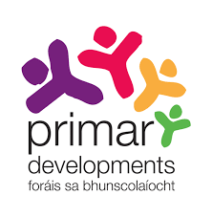

Draft Primary Mathematics Curriculum
Written submission template for organisations, groups and individuals responding to the Draft Primary Mathematics Curriculum
This template is intended to support you (and your colleagues/organisation) in developing a written submission in response to the Draft Primary Mathematics Curriculum. Please e-mail your completed submission to pmc.submissions@ncca.ie
Individual submission details
Name
Date
E-mail

Organisation submission details
Name
Position
Organisation
Date
E-mail

The NCCA will publish written submissions received during the consultation. The submissions will include the author’s/contributor’s name/organisation. Do you consent to this submission being posted online?
Yes No

Please provide some brief background information on your organisation (if applicable).

The remainder of the template includes two sections. Section 1 invites your overall comments and observations on the Draft Primary Mathematics Curriculum. Section 2 is structured to align with main sections of the draft curriculum.
  - Section 1
Please outline your overall response to the Draft Primary Mathematics Curriculum.

  - Section 2
Rationale and Aims [see pages 9 – 14]
The rationale for the Draft Primary Mathematics Curriculum addresses the importance of mathematics in children’s lives, while the over-arching aim of the draft curriculum is the development of mathematical proficiency.
Please give your overall feedback in relation to the Rationale and Aims.

Curriculum structure - Strands, Learning Outcome Labels, Elements and Learning Outcomes [see pages 15 – 24]
The Draft Primary Mathematics Curriculum is structured according to five Strands: Algebra; Data and Chance; Measures; Number; Shape and Space. Attached to these Strands are 15 Learning Outcome Labels, which contain Learning Outcomes for each stage.
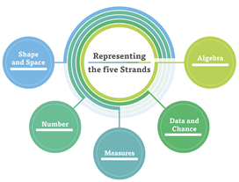
Mathematical processes are categorised into four Elements: Understanding and Connecting; Communicating; Reasoning; Applying and Problem solving.
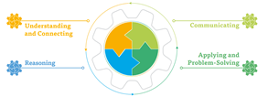
Please give your overall feedback in relation to the curriculum components mentioned above. Please quote full text of any learning outcome you wish to draw attention to.

The Primary Mathematics Curriculum in Practice [see pages 25 – 37]
The Draft Primary Mathematics Curriculum proposes five key pedagogical approaches which underpin and embody a new vision for children’s learning in terms of teachers’ everyday practice.
Please give your overall feedback in relation to these key pedagogical approaches.

Primary Mathematics Toolkit
The Primary Mathematics Toolkit will contain four components: Mathematical Concepts, Progression Continua, Support Materials and Examples of Children’s Learning. For consultation, the Draft Overview of the Primary Mathematics Toolkit contains Mathematical Concepts, Progression Continua and 11 Support Materials.
Please give your overall feedback in relation to the supports outlined and suggestions on additional supports.

Data Protection
The NCCA fully respects your right to privacy. Any personal information which you volunteer to the NCCA will be treated with the highest standards of security and confidentiality, strictly in accordance with the Data Protection Acts. If you require further information related to data protection please visit www.ncca.ie/en/privacy-statement or you can contact the NCCA's Data Protection Officer at dpo@ncca.ie.

