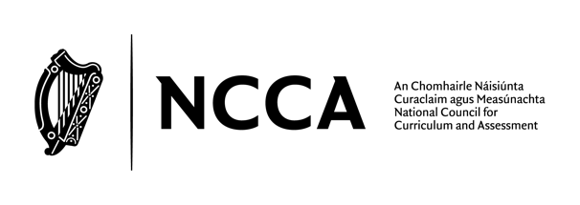

  - Draft specification
  - for Senior Cycle SPHE
NCCA consultation, 2023

NCCA consultation on draft specification for Senior Cycle SPHE

The NCCA is currently updating the Social, Personal and Health Education (SPHE) curriculum and as part of this work an updated Senior Cycle SPHE curriculum is now available for consultation. A key part of the consultation is feedback from individuals and groups who are interested in this area of young people’s education. The consultation on the draft Senior Cycle SPHE curriculum will remain open until October 18th . You can share your feedback by completing this template and sending it to: SPHEdevelopments@ncca.ie

Before completing the template, please read the draft Senior Cycle SPHE curriculum at this link: https://ncca.ie/en/senior-cycle/curriculum-developments/senior-cycle-social-personal-and-health-education-sphe/

Data Protection Statement
The NCCA is committed to protecting your privacy and does not collect any personal information about you through this template, other than the information you provide. Any personal information you volunteer to the NCCA will be respected in accordance with the highest standards of security and confidentiality in accordance with GDPR (2016) and the Data Protection Act (2018).

NCCA, as a public body operating under the Open Data and Public Service Information Directive (2021), is required to publish publicly funded research. All data from this survey will be further anonymised and aggregated before being published and only made available after the final report on this consultation is completed. Further information on the NCCA’s Data Protection Policy can be found here.

Senior Cycle SPHE – Feedback

If you are contributing your views an individual, please provide details below

Name:
Email address:
Do you wish to be listed as a contributor to this consultation on the NCCA website? | Yes/No
Do you wish to have your written submission published on the NCCA website? | Yes/No

If you are contributing your views on behalf of an organisation or group, please provide details below
Name:
Email address:
Name of organisation/group:
Does your organisation wish to be listed as a contributor to this consultation on the NCCA website? | Yes/No
Does your organisation wish to have this written submission published on the NCCA website? | Yes/No

Questions to consider

Question 1: Aim
The aim of the updated curriculum is to ‘empower students to become healthy, resilient, responsible and empathetic young adults; nurture respectful and caring relationships; and prepare for the opportunities, responsibilities and experiences of life now and beyond school.’

Please state whether you agree this aim summarises the purpose of SPHE for senior cycle students and your reason for agreeing/disagreeing.

Insert response here:

Question 2: The Learning
The draft course is structured around three strands and three cross­cutting elements, illustrated below:
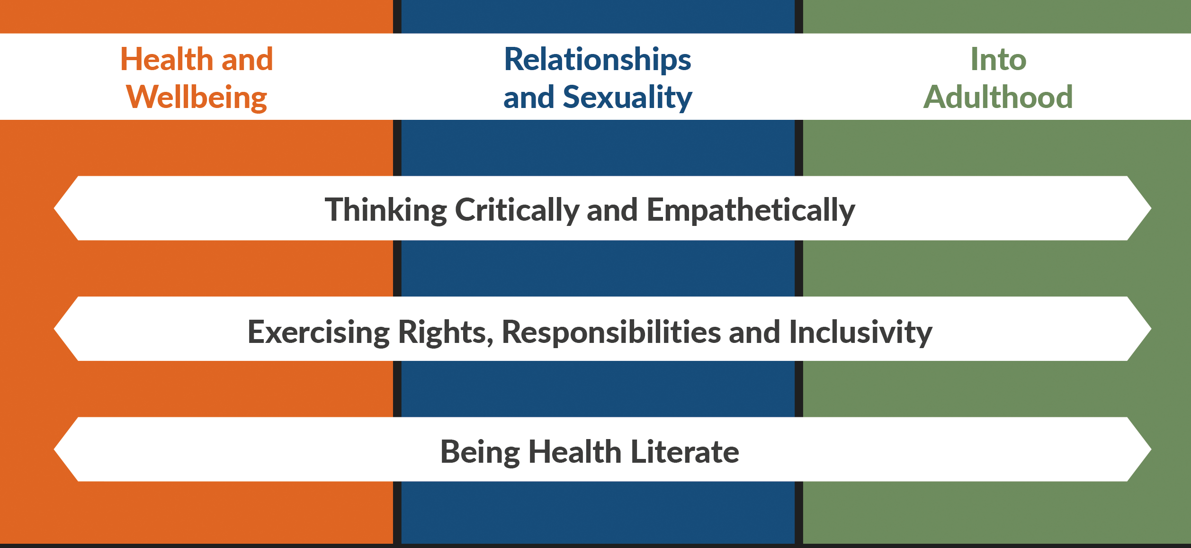
Below provides extracts from the draft specification. See draft specification pp 11–15 for a more detailed outline of the learning.

In the following section, we would value your feedback on each of the three strands.

Strand 1: Health and Wellbeing
Within this strand, students will explore the factors that influence their physical, social, emotional and mental health and the relationships between these aspects of health. They will learn ways to take care of themselves and stay as healthy as possible, with a particular focus on gaining awareness, skills, techniques and information to protect their mental health and wellbeing.

Students should be able to
1.1 | research the determinants of good health
1.2 | discuss the enablers and barriers to managing a healthy life balance - including study, work, play, sleep, people, ‘me time’, and ways to manage greater balance
1.3 | critically analyse the origins and effects of social norms and attitudes to alcohol and drugs
1.4 | explore the factors that influence mental health and wellbeing, including the influence of family, peers, societal attitudes, media, technology, alcohol and drugs, and one’s sense of self
1.5 | recognise unhelpful thinking patterns and negative self-talk and how these can affect emotions and behaviour
1.6 | draw on a variety of strategies that can help regulate and manage harmful thoughts and emotions in order to nurture positive mental health
1.7 | recognise the signs and symptoms of stress and anxiety in themselves and others and recognise when help should be sought, where to go and how to access help if needed
1.8 | discuss healthy and unhealthy ways of responding to stress and anxiety
1.9 | explain the pathways towards addiction, the signs and consequences of different kinds of addictions and where to go and how to access help, if needed
1.1 | discuss and devise ways to safely manage social situations where their own or others’ health or safety may be at risk.

Having considered the learning outcomes in Strand 1, please comment on whether you think the learning outcomes provide (a) clarity on expectations for learning in Senior Cycle SPHE and whether you consider the learning outcomes to be (b) relevant to the lives and needs of 16-18 year olds today. Please also let us know if you think anything important is missing from this Strand.

Insert response here:

Strand 2: Relationships and Sexuality
Within this strand students will explore the wide range of relationships that are important for their lives with a particular focus on gaining the awareness, knowledge and skills to support them in creating and nurturing respectful, caring and healthy relationships. This strand also supports students to recognise and be empowered to respond to instances of abuse or violence in relationships.

Note: Each of the learning outcomes below should be taught in a way that LGBTQ+ identities, relationships and families are fully integrated and reflected in teaching and learning, as opposed to being addressed within stand-alone lessons.

Students should be able to
2.1 | demonstrate the awareness and skills needed for nurturing healthy in-person and online relationships, including respecting boundaries, communicating feelings and needs and preventing and managing conflict
2.2 | reflect on how their attitudes, beliefs, values and identity can influence the dynamics of friendships, relationships and sexual behaviour
2.3 | discuss sexual activity as an aspect of adult relationships characterised by care, respect, consent, intimacy and mutual pleasure
2.4 | examine how harmful attitudes around gender are perpetuated in the media, online and in society and discuss strategies for challenging these attitudes and narratives
2.5 | identify and consider common signs of abusive relationships, including coercive control
2.6 | explain the root causes and consequences of gender-based violence (GBV), with a particular focus on violence against women and girls, and outline the supports available
2.7 | investigate the influence of pornography on attitudes, behaviours and relationship expectations
2.8 | discuss image-based abuse, sexual harassment, sexual assault and rape and what to do if they or someone they know has experienced any of these
2.9 | explore sexual and reproductive health, including fertility, safer sexual practices, possible responses to an unplanned pregnancy, and how to access sexual health services.

Having considered the learning outcomes in Strand 2, please comment on whether you think the learning outcomes provide (a) clarity on expectations for learning in Senior Cycle SPHE and whether you consider the learning outcomes to be (b) relevant to the lives and needs of 16–year olds today. Please also let us know if you think anything important is missing from this Strand.

Insert response here:

Strand 3: Into Adulthood

Within this strand students will gain specific knowledge and skills to support them as they make the transition to adulthood and learn how to take greater responsibility for themselves. This includes being able to manage choices, develop the skills that are needed to plan for the future, establish and maintain good habits, and achieve goals. It also supports students in learning how to take care of themselves in times of change or challenge, understand their rights and responsibilities before the law, and build the skills needed to be a good ally to those experiencing discrimination or inequality.

Students should be able to
3.1 | explore strategies for self-care that can help maintain health and prevent ill-health
3.2 | demonstrate self-management skills necessary for life
3.3 | explore a range of life events where they might experience change, loss or heartache and discuss how to care for themselves and/or others during these times
3.4 | summarise accurately their rights and responsibilities before the law as a young adult with reference to online communicating, age of consent, alcohol and drug use, their right to access services and work-place rights
3.5 | consider the skills needed to stand up for themselves and others, and the range of situations where this might arise
3.6 | demonstrate allyship skills to challenge unfair or abusive behaviours and support greater equity and inclusion.

Having considered the learning outcomes in Strand 3, please comment on whether you think the learning outcomes provide (a) clarity on expectations for learning in Senior Cycle SPHE and whether you consider the learning outcomes to be (b) relevant to the lives and needs of 16–18 year olds. Please also let us know if you think anything important is missing from this Strand.

Insert response here:

Question 3: Any further suggestions

We would appreciate any further suggestions for how the draft updated Senior Cycle SPHE curriculum could be improved?

Insert response here:

Thank you for taking the time to share your views with us. Please email this document to SPHEdevelopments@ncca.ie before October 18th, 2023

